T1 -

1. BCrypts: Completed

Users in db:

1. Form validator and length limits: Completed

**Register form validation**

**Register Client side:**



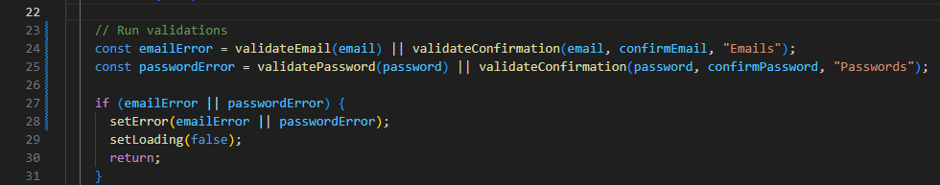

**Register Server side:**

**Login form validation:**

**Client Side:**

**Server side:**

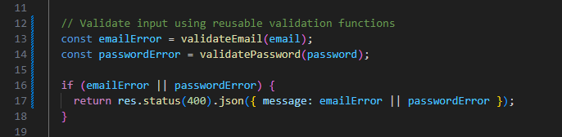

**formValidator.js handles all validation centrally:**

1. Email and Pass match check: Completed

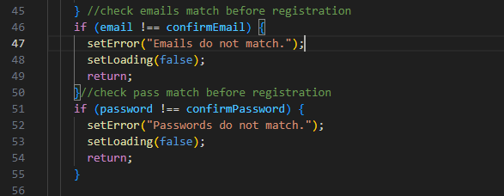

1. In all input field ensure Escaped: Started/completed:

